MINISTRY OF EDUCATION AND SCIENCES, YOUTH AND SPORT OF UKRAINE
TERNOPIL NATIONAL ECONOMIC UNIVERSITY
UKRAINIAN-DUTCH FACULTY OF ECONOMICS AND MANAGEMENT

Business Communication and Organizational Behavior Department

COMPLEX PRACTICAL INDIVIDUAL TASK REPORT

Discipline: Self-Management
Group: ____________________________
Student’s Name______________________
Supervisor: N.V. Batryn

Ternopil - 2001
Self-management means different things in different fields. In business, education, and psychology, self-management refers to methods, skills, and strategies by which individuals can effectively direct their own activities toward the achievement of objectives, and includes goal setting, decision making, focusing, planning, scheduling, task tracking, self-evaluation, self-intervention, self-development, etc. Self-analysis involves any process of examining your current range of strengths, weaknesses, skills, competences, etc.
TASK 1. SWOT ANALYSIS
You should undertake this activity prior to completing any other form of self-analysis, as it is best to do this with a completely open mind before you are affected by any other external factors. Split a page in your learning log into four:
Using the instructions on the previous page, note down everything that you consider being your strengths, weaknesses, opportunities and threats. Ask your friend to write down SWOT analysis for you. My Friend’s SWOT Analysis means what your friend thinks about you. Compare and analyze.

 | My Personal SWOT Analysis
 | Strengths | Weaknesses | Opportunities | Threats
1
2
3
4
5

 | My Friend’s SWOT Analysis
 | Strengths | Weaknesses | Opportunities | Threats
1
2
3
4
5

Comparative Analysis
__________________________________________________________________________________________________________________________________________________________________________________________________________________________________________________________________________________________________________________________________________________________________________________________________________________________________________________________________________________________________________________________________________________________________________________________________________________

TASK 2. CIRCLE OF LIFE
Grade each characteristic according to 10-point system and connect them. Analyze if you are satisfied with what you received and explain what you will do to achieve better results. | 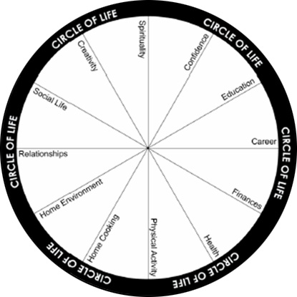

Analysis
____________________________________________________________________________________________________________________________________________________________________________________________________________________________________________________________________________________________________________________________________________________
_______________________________________________________________________________________________________________________________________________________________________________________________________________________________________________________________________________________________________________________________________________________________________________________________________________________________________________________________________________________________________________________________________________________________________________________________________________________________________________________________________________________________________________________________________________________________________________________________________________________________________________________________________________________________________________________________________________________________________
TASK 3. Constructing your self-development plan.
The way to work out how you are going to fill your self-development gap and meet your self-development needs is to list your needs and match them with the most effective form of learning that will meet each need. Your development plan needs to show your development objectives, what you intend to do to meet your development needs and when you will review your progress against your plans. Ideally your development plan should include a range of learning activities which suit your learning style, and include a balance of both formal and informal learning experiences.

Development  objectives | Proposed action
Development  objectives | Proposed  development | Date  development  undertaken | Review  date | Outcomes of  development activity  and review comments | Further action
1
2
3
4

Analysis
______________________________________________________________________________________________________________________________________________________________________________________________________________________________________________________________________________________________________________________________________________________________________________________________________________________________________________________________________________________________________________________________________________________________________________________________________________________________________________________________________________________________________________________________________________________________________________________________________________________________________________________________________________________________________________________________________________________________________________________________________________________________________________________________________________________________________________________

TASK 5. Motivational “Meat Grinder“.
Write down all the possible motivational factors that motivate you personally to work and to study. In the Analysis write down the possible factors based on theories of motivation.

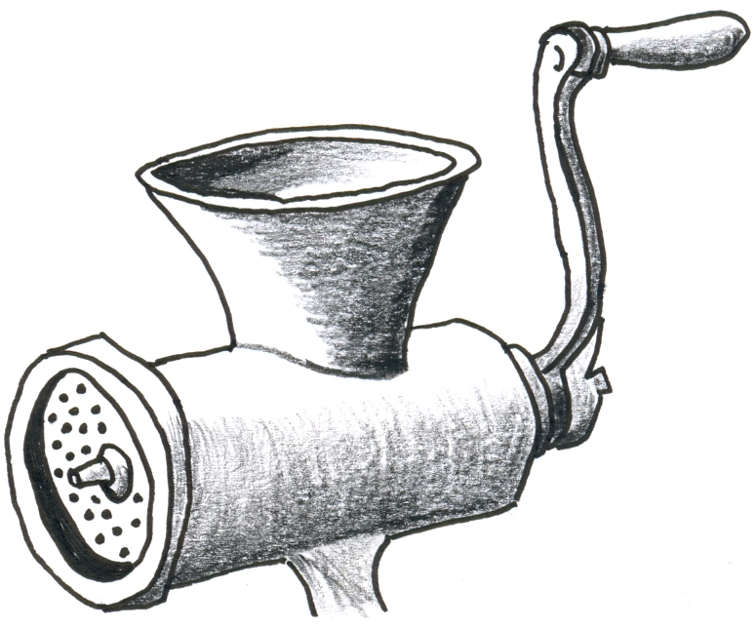

Analysis
______________________________________________________________________________________________________________________________________________________________________________________________________________________________________________________________________________________________________________________________________________________________________________________________________________________________________________________________________________________________________________________________________________________________________________________________________________________________________________________________________________________________________________________________________________________________________________________________________________________________________________________________________________________________________________________________________________________________________________________________________________________________________________________________________________________________________________________________________________________________________________________________________________________________________

TASK 6. TIME-MANAGEMENT
Obviously you cannot control time in the sense of stopping it, slowing it down or speeding it up. But you can apply it economically to the tasks you have to accomplish.
Complete the table and analyze your relationship with the way you spend your time.

 | Time | Activity | Evaluation | Conclusion
1 | 7.00 – 8.00
2 | 8.00 – 9.00
3 | 9.00 – 10.00
4 | 10.00 – 11.00
5 | 11.00 – 12.00
6 | 12.00 – 13.00
7 | 13.00 – 14.00
8 | 14.00 – 15.00
9 | 15.00 – 16.00
10 | 16.00 – 17.00
11 | 17.00 – 18.00
12 | 18.00 – 19.00
13 | 19.00 – 20.00
14 | 20.00 – 21.00
15 | 21.00 -22.00
16 | 22.00 -23.00

Analysis
___________________________________________________________________________________________________________________________________________________________________________________________________________________________________________________________________________________________________________________________________________________________________________________________________________________________________________________________________________________________________________________________________________________________________________________________________________________________________________________________________________________________________________________________________________________________________________________________________________________________________________________________________________________________________________________________________________________________________________________________________________________________________________________________________________________________________________________________________________________________________________________________________________________________________________________________________________________________________________________________________________________________________________________________________________________________________________________________________________________________________________________________________________________________________________________________________________________________________________________________________________________________________________________________________________________________________________________________________________________________________________________________________________________________________________________________________________________________________________________________________________________________________________________________________________________________________________________________________________________________________________________________________________________________________________________________________________________________________________________________________________________________________________________________________________________________________________________________________________________________________________________________________________________________________________________________________________________________________________________________________________________________________________________________________________

