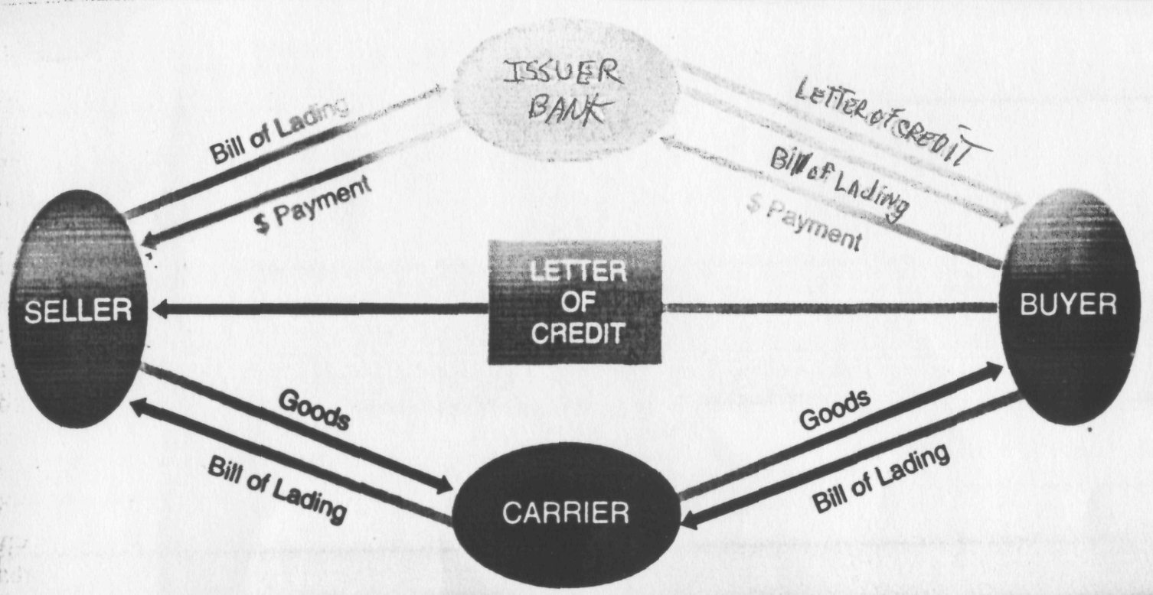

CHRONOLOGY OF EVENTS

- Buyer contracts with issuer bank to issue a letter of credit; this sets forth the bank's obligation to pay on the letter of credit and buyer's obligation to pay the bank.
- Letter of credit is sent to seller informing seller that on compliance with the terms of the letter of credit (such as presentment of necessary documents—in this example, a bill of lading), the bank will issue a payment for the goods.
- Seller delivers goods to carrier and receives a bill of lading.
- Seller delivers the bill of lading to issuer bank and, if the document is proper, receives payment.
- Issuer bank delivers the bill of lading to buyer.
- Buyer delivers the bill of lading to carrier.
- Carrier delivers the goods to buyer.
- Buyer settles with issuer bank.
